Praneesh R V

CB.SC.U4CYS23036

Code:

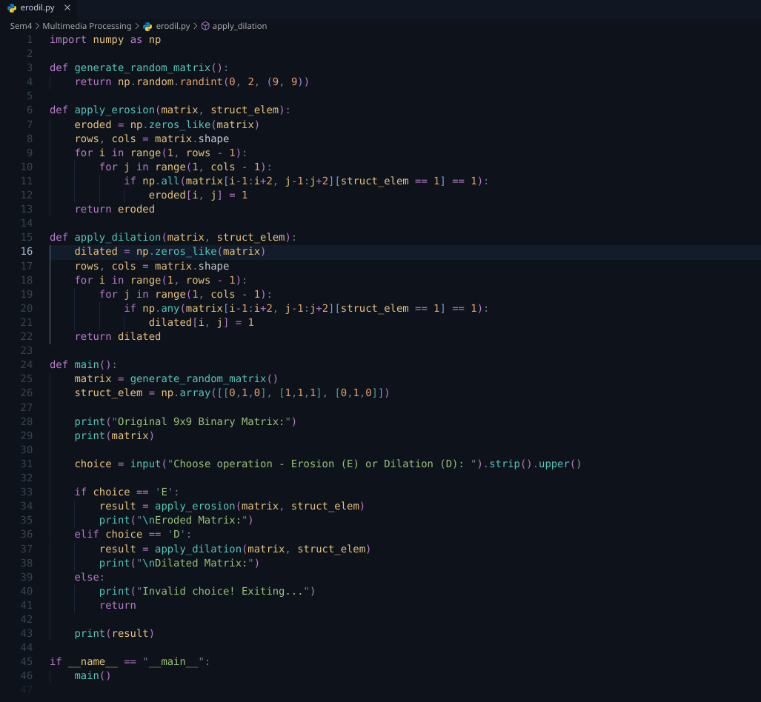

Output:

